**Supplementary material**: Optimal capacity planning for the electrification of personal transport: The interplay between flexible charging and energy system infrastructure

# The number of cars and electric vehicles based on scenarios

In the following, we provide the number of passenger cars and EVs based on projections from the Swiss Transport Outlook [1] for two scenarios: Basis and SuS. The Basis scenario foresees that the development of transport sector will be business-as-usual. While for SuS, they foresee that sustainable policies will be promoted (i.e., promoting EVs or other modes of transportation such as local transportation or bikes). For the third scenario named Full electrification we assume that all the personal cars are electric by 2050. The number of EVs are extracted by extrapolation between the current and future number of cars by 2050.

Fig. 1. The number of EVs for three scenarios from 2020-2050.

Table 1. The number of cars, EVs, and share of EVs for Basis scenario based on Transport Outlook of Switzerland 2050.

|  |  |  |  |  |  |  |  |
| --- | --- | --- | --- | --- | --- | --- | --- |
| **Basis** | **2020** | **2025** | **2030** | **2035** | **2040** | **2045** | **2050** |
| **Nr of cars** | 4780836 | 4833858 | 4930419 | 4990744 | 5014152 | 5015042 | 5002379 |
| **Nr of EVs** | 36654 | 139395 | 349172 | 669085 | 1055215 | 1467135 | 1904568 |
| **Share of EVs** | 0.77% | 2.88% | 7.08% | 13.41% | 21.04% | 29.25% | 38.07% |

Table 2. The number of cars, EVs, and share of EVs for SuS scenario based on Transport Outlook of Switzerland 2050.

|  |  |  |  |  |  |  |  |
| --- | --- | --- | --- | --- | --- | --- | --- |
| **SuS** | **2020** | **2025** | **2030** | **2035** | **2040** | **2045** | **2050** |
| **Nr of cars** | 4780836 | 4754531 | 4760823 | 4731716 | 4661231 | 4560624 | 4448615 |
| **Nr of EVs** | 36654 | 158409 | 478958 | 1074893 | 1880054 | 2662102 | 3281742 |
| **Share of EVs** | 0.77% | 3.33% | 10.06% | 22.72% | 40.33% | 58.37% | 73.77% |

Table 3. The number of cars, EVs, and share of EVs for Full electrification.

|  |  |  |  |  |  |  |  |
| --- | --- | --- | --- | --- | --- | --- | --- |
| **Full electrification** | **2020** | **2025** | **2030** | **2035** | **2040** | **2045** | **2050** |
| **Nr of cars** | 4780836 | 4833858 | 4930419 | 4990744 | 5014152 | 5015042 | 5002379 |
| **Nr of EVs** | 36654 | 286247 | 765398 | 1476612 | 2419890 | 3595232 | 5002379 |
| **Share of EVs** | 0.77% | 5.92% | 15.52% | 29.59% | 48.26% | 71.69% | 100% |

# Charging profiles for each spatial settings

The charging profiles for EVs is modelled as shown in the Methodology section. Three main steps have been followed: first we extract the input data from Swiss NHTS, than we build the charging profiles based on the input data and lastly we calculate the demand based. To build charging profiles we focus on the second step. The main input data from Swiss NHTS we used to create charging profiles are location, spatial settings, day, arrival time and distance. In the following we show a typical daily charging profile per EV for the three urban setting.

Fig. 2. Typical EV charging profiles for RUR, SUB, and URB, derived from Swiss NHTS. The highest demand is expected to be after working hours (18:00-19:00). The charging profiles are given for uncontrolled charging on basis that people start to charge once they arrive at home. Controlled charging profiles are endogenously determined by the optimizer based on time window we pre-defined (e.g., in our study the time window selected was 24h, 60h, and 120h).

# Energy demand for electric vehicles

To calculate energy demand, we multiply the charging profiles (per EV) by the driving frequency and number of EVs. The following figure (Fig. 2) show the energy demand for each spatial settings and in national level throughout a week.

Fig. 3. Weekly energy demand from EVs by 2050 (full electrification scenario). We observe that for uncontrolled charging the peak demand can reach as high as 8000 MW. To illustrate, the average electricity consumption per hour of Switzerland during 2022 was 7400 MW, while the peak demand was 10200 MW based on [2].

Fig. 4. Weekly energy demand from EVs based on RUR, SUB, and URB, by 2050 (full electrification scenario). The most demand comes from RUR that is 8% and 16% higher for SUB and RUR, respectively. The weekly energy demand for RUR, SUB, and URB is 127253, 116931, and 106945, respectively.

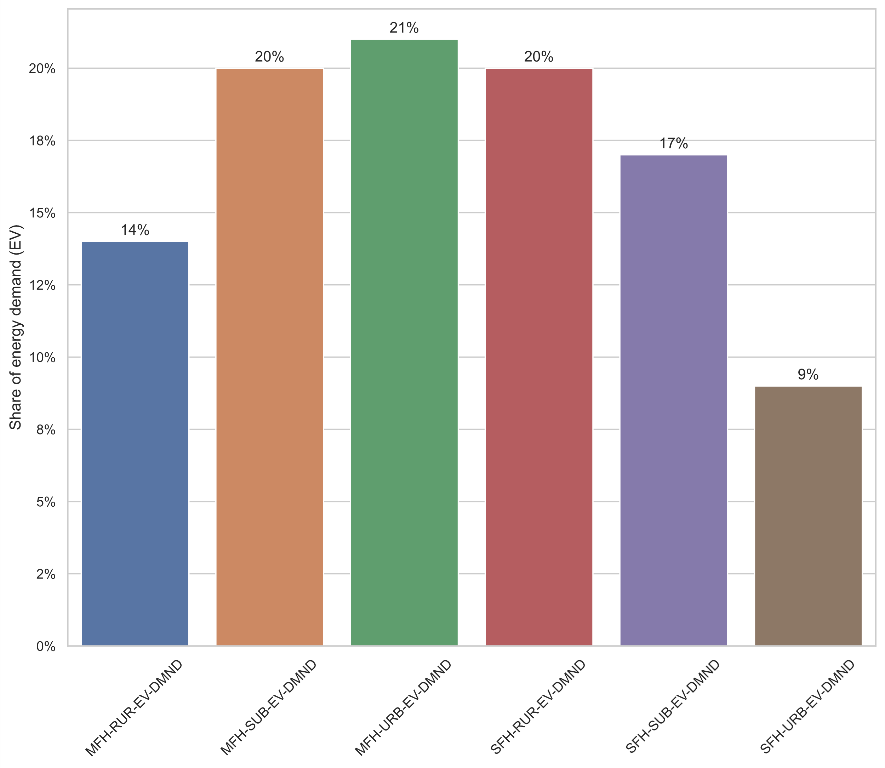

Fig. 5. The share of energy demand required from EVs under three spatial settings and two building archetypes.

The additional energy demand from electric vehicles (EVs) is given in the following table. The electrification and integration of EVs in GRIMSEL is shown in open-source GRIMSEL-EV the input data are based on real driving behavior from Swiss National Household Travel Survey (NHTS). The additional electricity demand of EVs is given for residential building archetypes (SFH and MFH) across three spatial areas (rural/RUR, suburban/SUB and urban/URB).

Table 4. Energy demand for EVs for residential building archetypes (SFH and MFH) across three spatial settings from 2015-2050. The energy demand is given per year (MWh/ annual) for the scenario for full electrification. The additional energy demand from EVs by 2050 is 10.45 (TWh/ annual).

|  |  |  |  |  |  |  |
| --- | --- | --- | --- | --- | --- | --- |
| **Year** | **MFH-RUR** | **MFH-SUB** | **MFH-URB** | **SFH-RUR** | **SFH-SUB** | **SFH-URB** |
| 2020 | 10615.98 | 15244.30 | 15855.23 | 15332.30 | 12970.56 | 6518.04 |
| 2025 | 82902.58 | 119046.18 | 123817.09 | 119733.36 | 101290.03 | 50900.81 |
| 2030 | 221673.71 | 318318.29 | 331075.25 | 320155.74 | 270840.01 | 136103.98 |
| 2035 | 427654.82 | 614102.39 | 638713.22 | 617647.21 | 522506.88 | 262572.98 |
| 2040 | 700845.93 | 1006398.47 | 1046731.00 | 1012207.77 | 856290.64 | 430307.79 |
| 2045 | 1041247.02 | 1495206.54 | 1555128.59 | 1503837.41 | 1272191.29 | 639308.42 |
| 2050 | 1448783.51 | 2080419.47 | 2163794.58 | 2092428.40 | 1770117.68 | 889529.08 |

# Energy demand for heat pumps

The additional energy demand from heat pumps (HPs) which represents full electrification of residential heating sector in this study is given in the following table. The input data for the electrification and integration of HPs in GRIMSEL-EV is based on [3]. The demand from HPs is given for residential building archetypes (SFH and MFH) across three spatial areas (rural/RUR, suburban/SUB and urban/URB). A comparison between electrification of heating and transportation is given in the Fig. 3.

Table 5. Energy demand for HPs for residential building archetypes (SFH and MFH) across three spatial settings from 2020-2050. The energy demand is given per year (MWh/ annual) for full heat electrification. The additional energy demand from HPs by 2050 is 8.47 (TWh/annual).

|  |  |  |  |  |  |  |
| --- | --- | --- | --- | --- | --- | --- |
| **Year** | **MFH-RUR** | **MFH-SUB** | **MFH-URB** | **SFH-RUR** | **SFH-SUB** | **SFH-URB** |
| 2020 | 113325.38 | 291200.73 | 203686.14 | 251700.88 | 287431.08 | 62141.33 |
| 2025 | 226650.75 | 582401.46 | 407372.29 | 503401.76 | 574862.15 | 124282.66 |
| 2030 | 339976.13 | 873602.19 | 611058.43 | 755102.63 | 862293.23 | 186423.98 |
| 2035 | 453301.50 | 1164802.92 | 814744.58 | 1006803.51 | 1149724.31 | 248565.31 |
| 2040 | 566626.88 | 1456003.65 | 1018430.72 | 1258504.39 | 1437155.38 | 310706.64 |
| 2045 | 679952.26 | 1747204.39 | 1222116.87 | 1510205.27 | 1724586.46 | 372847.97 |
| 2050 | 793277.63 | 2038405.12 | 1425803.01 | 1761906.15 | 2012017.53 | 434989.29 |

# The comparison between EV and HP energy demand

In Fig. 2 we show the energy demand required from HPs and EVs by 2050 for each residential archetype and spatial area.

Fig. 6. The comparison in energy demand between HPs and EVs across building archetypes and urban settings by 2050. The highest share of energy demand from HPs comes from MFH_SUB and SFH_SUB (approximately 2 TWh/annual) followed by SFH_RUR. The lowest demand required is at MFH_RUR. Regarding to EVs the highest share of energy demand required is at MFH_URB, MFH_SUB, and SFH_RUR (approximately 2.1 TWh/annual), and the lowest at SFH_URB. By 2050, the required energy demand from EVs (10.45 TWh/annual) is higher than HPs (8.47 TWh/annual).

# The PV potential in Switzerland for residential prosumers

For each archetype PV potential was assigned to GRIMSEL-EV. The PV potential was estimated based on Sonnendach database which contains information (irradiance, orientation, areas) of every roof in Switzerland. Based on [4] information of each building and information from Sonnendach the potential for each archetype is assigned. A detailed description of PV potential assignment and the integration in GRIMSEL is depicted in [5].

Table 6. The PV potential for SFH and MFH across three spatial settings, based on [5]. The highest PV potential lies in SFH (RUR and SUB), followed by MFH in URB and SUB.

|  |  |  |  |  |  |  |
| --- | --- | --- | --- | --- | --- | --- |
| Nodes | **MFH-RUR** | **MFH-SUB** | **MFH-URB** | **SFH-RUR** | **SFH-SUB** | **SFH-URB** |
| PV potential ( ${MW}_{peak})$ | 2070 | 2520 | 3451 | 7983 | 5791 | 2417 |

# Installed storage capacity (Li-ion and VRFB)

The installed storage capacity (Li-ion and VRFB) for three EV scenarios (Basis, SuS, and Full electrification).

Table 7. Total installed storage capacity (Li-ion and VRFB) under three scenarios for three spatial settings. The installed capacities are given for **uncontrolled charging** (1h) while the numbers in parenthesis are for **full controlled charging** (full flexibility or 120h). The capacities are given for **default distribution grid** scenario (Default) and units are in MW.

|  |  |  |  |  |  |  |
| --- | --- | --- | --- | --- | --- | --- |
|  | **Rural** | | **Suburban** | | **Urban** | |
| Li-ion | VRFB | Li-ion | VRFB | Li-ion | VRFB |
| **Basis** | | | | | | |
| 2030 | 655 (650) | - | 705 (630) | - | - | - |
| 2040 | 6260 (5820) | 1690 (1830) | 3520 (3420) | 630 (620) | - | - |
| 2050 | 7930 (6750) | 2180 (2180) | 8370 (6260) | 1790 (1430) | 990 (0) | - |
| **SuS** | | | | | | |
| 2030 | 680 (650) | - | 740 (625) | - | - | - |
| 2040 | 6430 (5710) | 1710 (1880) | 3720 (3500) | 640 (610) | - | - |
| 2050 | 8940 (6690) | 2400 (2330) | 11800 (8560) | 5180 (5140) | 1060 (0) | - |
| **Full electrification** | | | | | | |
| 2030 | 770 (650) | - | 795 (625) | - | - | - |
| 2040 | 6710 (5640) | 1670 (1910) | 3890 (3240) | 690 (780) | 80 (0) | - |
| 2050 | 11470 (7380) | 3330 (3075) | 15740 (10210) | 14340 (15170) | 1040 (0) | - |

Table 8. Total installed storage capacity (Li-ion and VRFB) under three scenarios for three spatial settings. The installed capacities are given for **uncontrolled charging** (1h) while the numbers in parenthesis are for **full controlled charging** (120h). The capacities are given for **+15% grid reinforcement** scenario and units are in MW.

|  |  |  |  |  |  |  |
| --- | --- | --- | --- | --- | --- | --- |
|  | **Rural** | | **Suburban** | | **Urban** | |
| Li-ion | VRFB | Li-ion | VRFB | Li-ion | VRFB |
| **Basis** | | | | | | |
| 2030 | 700 (700) | - | 720 (680) | - | - | - |
| 2040 | 6040 (5760) | 1570 (1700) | 3290 (3170) | 590 (640) | - | - |
| 2050 | 7390 (6840) | 1950 (1950) | 5180 (4170) | 770 (815) | 420 (0) | - |
| **SuS** | | | | | | |
| 2030 | 720 (700) | - | 760 (670) | - | - | - |
| 2040 | 6110 (5770) | 1590 (1690) | 3340 (3195) | 610 (630) | - | - |
| 2050 | 7950 (6770) | 1940 (1990) | 5820 (4250) | 960 (950) | 400 (0) | - |
| **Full electrification** | | | | | | |
| 2030 | 830 (700) | - | 820 (675) | - | - | - |
| 2040 | 6240 (5670) | 1590 (1730) | 3360 (3200) | 630 (625) | - | - |
| 2050 | 8780 (6540) | 1990 (2130) | 8930 (5610) | 1270 (1230) | 325 (0) | - |

# Costs for PV and stationary battery storage in Switzerland

The costs for PV and stationary battery storage (Li-ion and VRFB) including investment costs and O & M are given in Table. 1, based on [3], [6]. The costs are given for SFH and MFH, while the costs for related to industry (IND) and offices and commercial buildings (OCO) can be find on the same studies.

Table 9. Investment and operational costs for PV and storage for residential archetypes in 2015, 2035 and 2050.

|  |  |  |  |  |  |
| --- | --- | --- | --- | --- | --- |
|  |  | Unit | 2015 | 2035 | 2050 |
| Residential  (SFH and MFH) | Residential  (SFH and MFH) | Residential  (SFH and MFH) |
| PV | Investment costs | CHF/kW | 2451.5 | 1270 | 1101 |
|  | O&M costs | CHF/kW/year | 103 | 68.5 | 62.5 |
|  | Lifetime | Years | 27.5 | 27.5 | 27.5 |
| LiB | Investment costs | CHF/kW | 1977.5 | 391.4 | 391.4 |
|  | O&M costs | %inv/year | 1.5 | 1.5 | 1.5 |
|  | Lifetime | Years | 15 | 15 | 15 |
| VRFB | Investment costs | CHF/kW | 3501.9 | 846.5 | 846.5 |
|  | O&M costs | %inv/year | 1.5 | 1.5 | 1.5 |
|  | Lifetime | Years | 15 | 15 | 15 |

# Levelized cost of storage (LCOES) in Euro/MWh

Table 10. The LCOES for new installed storage capacities (Li-ion and VRFB). The numbers in bracket are the new installed capacities in MW. The values are given for **uncontrolled** **charging** with **no grid capacity reinforcements** (default).

|  |  |  |  |  |  |
| --- | --- | --- | --- | --- | --- |
| **Nodes** | **2030** | **2035** | **2040** | **2045** | **2050** |
| **SFH** | - | 70.79 (21) | 85.73 (376) | 110.16 (2050) | 127.9 (5825) |
| **MFH** | 148.1 (2) | 69.98 (73) | 114.08 (442) | 131.9 (3431) | 477.35 (19500) |
| **OCO** | - | 87.84 (1560) | 129.28 (2022) | 101.28 (1970) | 133.42 (130) |
| **IND** | 89.78 (1563) | 95.78 (7000) | - | - | - |

Table 11. The LCOES for new installed storage capacities (Li-ion and VRFB). The numbers in bracket are the new installed capacities in MW. The values are given for **uncontrolled charging** with **+15% grid capacity reinforcements**.

|  |  |  |  |  |  |
| --- | --- | --- | --- | --- | --- |
| **Nodes** | **2030** | **2035** | **2040** | **2045** | **2050** |
| **SFH** | - | - | 74.75 (30) | 76.5 (560) | 87.84 (2600) |
| **MFH** | - | - | 70.75 (94) | 115.04 (550) | 115.33 (3900) |
| **OCO** | - | 80.12 (1860) | 125.4 (2150) | 88.7 (1810) | 173.75 (70) |
| **IND** | 86.9 (1653) | 94.2 (6026) | - | - | - |

Table 12. The LCOES for new installed storage capacities (Li-ion and VRFB). The numbers in bracket are the new installed capacities in MW. The values are given for **controlled charging** (120h - full flexibility) with **no grid capacity reinforcements** (default).

|  |  |  |  |  |  |
| --- | --- | --- | --- | --- | --- |
| **Nodes** | **2030** | **2035** | **2040** | **2045** | **2050** |
| **SFH** | - | - | - | 193.83 (200) | 174.05 (3200) |
| **MFH** | - | - | 372.33 (143) | 205.67 (1400) | 1213.52 (17100) |
| **OCO** | - | 94.62 (1125) | 125.68 (2250) | 104.5 (2230) | 146 (132) |
| **IND** | 90.71 (1300) | 104.65 (6800) | - | - | - |

Table 13. The LCOES for new installed storage capacities (Li-ion and VRFB). The numbers in bracket are the new installed capacities in MW. The values are given for **controlled charging** (120h - full flexibility) with +**15% grid capacity** **reinforcements**).

|  |  |  |  |  |  |
| --- | --- | --- | --- | --- | --- |
| **Nodes** | **2030** | **2035** | **2040** | **2045** | **2050** |
| **SFH** | - | - | - | - | 166 (195) |
| **MFH** | - | - | - | 593.73 (200) | 207.6 (1800) |
| **OCO** | - | 88.81 (1265) | 117.5 (2500) | 97.68 (2000) | 134.7 (100) |
| **IND** | 88.6 (1400) | 99.22 (6115) | - | - | - |

# Levelized cost of PV (LCOE) in Euro/MWh

Table 14. The LCOE for new installed PV capacities. The numbers in bracket are the new installed capacities in MW. The values are given for uncontrolled charging with no grid capacity reinforcements (default). For IND due to seized potential no additional PV are installed after 2035.

|  |  |  |  |  |  |
| --- | --- | --- | --- | --- | --- |
| **Nodes** | **2030** | **2035** | **2040** | **2045** | **2050** |
| **SFH** | - | 106.78 (3000) | 102.82 (185) | 98.87 (1080) | 94.91 (3000) |
| **MFH** | - | 106.78 (5400) | 102.82 (230) | 98.87 (774) | 94.91 (1100) |
| **OCO** | 80.66 (3800) | 68.47 (935) | 65.92 (1230) | 63.37 (940) | 60.82 (90) |
| **IND** | 42.06 (1100) | 32.83 (3420) | - | - | - |

Table 15. The LCOE for new installed PV capacities. The numbers in bracket are the new installed capacities in MW. The values are given for controlled charging (120h – full flexibility) with no grid capacity reinforcements (default).

|  |  |  |  |  |  |
| --- | --- | --- | --- | --- | --- |
| **Nodes** | **2030** | **2035** | **2040** | **2045** | **2050** |
| **SFH** | - | 106.87 (4130) | 102.82 (860) | 98.87 (750) | 94.9 (2300) |
| **MFH** | - | 106.78 (6530) | 102.82 (560) | 98.87 (230) | 94.9 (260) |
| **OCO** | 80.66 (3800) | 68.47 (770) | 65.92 (1300) | 63.37 (1050) | 60.82 (90) |
| **IND** | 42.06 (960) | 32.83 (3560) | - | - | - |

Table 16. The LCOE for new installed PV capacities. The numbers in bracket are the new installed capacities in MW. The values are given for controlled charging (120h – full flexibility) with grid capacity reinforcements by +15%.

|  |  |  |  |  |  |
| --- | --- | --- | --- | --- | --- |
| **Nodes** | **2030** | **2035** | **2040** | **2045** | **2050** |
| **SFH** | - | 106.78 (4250) | 102.82 (1200) | 98.87 (620) | 94.9 (850) |
| **MFH** | - | 106.78 (6530) | 102.82 (690) | 98.87 (200) | 94.9 (210) |
| **OCO** | 80.66 (3900) | 68.47 (825) | 65.92 (1400) | 63.37 (900) | 60.82 (70) |
| **IND** | 42.06 (960) | 32.83 (3160) | - | - | - |

**References**

[1] Federal Department of the Environment, Transport, Energy and Communications (DETEC), ‘Transport Outlook 2050’, Federal Office for Spatial Development, 2022.

[2] European Energy Network and Transmission System Operator, ENTSO-E, ‘Transparency Platform’. https://transparency.entsoe.eu/, Accessed on: May 10, 2023.

[3] A. Rinaldi, M. C. Soini, K. Streicher, M. K. Patel, and D. Parra, ‘Decarbonising heat with optimal PV and storage investments: A detailed sector coupling modelling framework with flexible heat pump operation’, *Applied Energy*, vol. 282, p. 116110, Jan. 2021, doi: 10.1016/j.apenergy.2020.116110.

[4] Office fédéral de la statistique, ‘Registre fédéral des bâtiments et des logements (RegBL)’, *geo.admin.ch*. https://map.geo.admin.ch (accessed Apr. 18, 2023).

[5] A. Rinaldi, M. C. Soini, M. K. Patel, and D. Parra, ‘Optimised allocation of PV and storage capacity among different consumer types and urban settings: A prospective analysis for Switzerland’, *Journal of Cleaner Production*, vol. 259, p. 120762, Jun. 2020, doi: 10.1016/j.jclepro.2020.120762.

[6] A. Rinaldi, S. Yilmaz, M. K. Patel, and D. Parra, ‘What adds more flexibility? An energy system analysis of storage, demand-side response, heating electrification, and distribution reinforcement’, *Renewable and Sustainable Energy Reviews*, vol. 167, p. 112696, Oct. 2022, doi: 10.1016/j.rser.2022.112696.